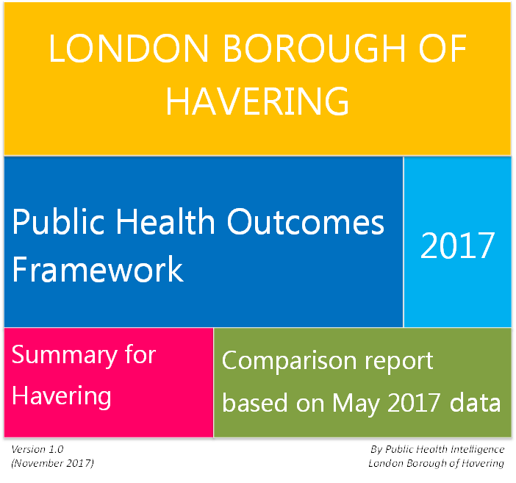

Contents

Introduction 1

Indicator highlights 1

Appendix 1: Ranking of all PHOF indicators 4

Indicators 4

How to read the tables 4

Domain - Overarching indicators 5

Domain - Improving the wider determinants of health 5

Domain - Health improvement 8

Domain - Health protection 11

Domain - Healthcare public health and preventing premature mortality 12

Appendix 2: Information about PHOF 15

# Introduction

This report summarises indicators on the health and wellbeing of residents of Havering and compares them with London and England. They have been prepared nationally for the Public Health Outcomes Framework[1] (PHOF) and describe:

* Overarching health (e.g. life expectancy)
* The determinants of health (e.g. education, employment and environment)
* Health improvement (e.g. obesity, diet and smoking)
* Health protection (e.g. vaccination)
* Healthcare and preventing early death (e.g. deaths under age 75 from heart disease)

The five areas cover 66 outcomes with a total of 219 indicators. Many are descriptive and not suitable as performance indicators as they relate to a whole lifetime, for example early death from lung cancer caused by 50 years of smoking. Others are more immediately changeable, for instance rates of attending screening for cancer. But action to achieve any change may be easier locally (school readiness) or nationally (childhood obesity). The detail of all the indicators and their rankings is given in the appendix, along with additional technical guidance and web links.

# Indicator highlights

For Havering the indicators are generally good. About 50% are the same as London or England, 35% are better and 15% are worse. Those that are worse are summarised by area below and some of those areas where Havering is better are also highlighted. The detail for all 219 indicators is in Appendix 2.

**Overarching health** – focuses on life expectancy and life expectancy in good health. All these indicators are the same as London. In comparison with England life expectancy tends to be better in Havering. To increase these all the indicators in the other areas need to improve.

**Improving the determinants of health** – Havering is significantly worse than London and England for pupil absence and for level of development at the end of Reception year for those receiving free school meals. These are probably alterable locally in the medium term. The third poor outcome is the proportion of adults with learning disability who live in stable and appropriate accommodation. This should be modifiable locally in the short term.

Havering is significantly better in some areas, particularly those related to crime and children living in low income families. Statutory homelessness is significantly better than London but still worse than England.

**Health improvement** –Locally the healthy behaviours that are significantly poor are: mothers who smoke during pregnancy and around delivery, initiating breast feeding, newborn hearing tests, children aged 10-11 years and adults who are overweight, eating *5-a-day*, attending bowel cancer screening, completing alcohol misuse treatment, released prisoners attending alcohol and drug services, and invitations and attendance at NHS Health Checks. These are modifiable locally in the short to medium term, apart from obesity that requires long term national action.

Havering is better than London and England for admission for alcohol related conditions, emergency admissions for self-harm, admissions for falls, and cancer screening rates.

**Health protection** –Havering has a significantly low rate of detecting Chlamydia in young people, and of vaccinating against a number of diseases (cervical cancer, pneumococcal disease, flu and shingles). Antibiotic prescribing rates are also significantly poor. All of these are modifiable locally in the short term.

Havering is significantly better than London (ranked 1 or 2) and England for childhood vaccination rates. For a London borough we have very low rates of TB, but we are similar to England as a whole.

**Healthcare related to public health and preventing early death** –The outcomes that are worse than London or England are the premature mortality rate from cancer (requires long-term solutions), the rate of emergency readmissions within 30 days of discharge from hospital (short-term measures would address this), the rate of hip fractures in people aged 65+ years and the rate of *excess* winter deaths in females aged 85+ years (both alterable in the medium term).

Reflecting better life expectancy in Havering compared with England (though similar to London), Havering has the lowest infant mortality in London and is also better than London and England for mortality form causes that are considered preventable. Most individual conditions therefore tend to have low premature mortality, though not necessarily significantly so.

Table 1: Havering PHOF indictors in comparison to London and England

|  |  |  |  |  |  |  |
| --- | --- | --- | --- | --- | --- | --- |
| **Domain** | **London** | | | **England** | | |
| Better | Same | Worse | Better | Same | Worse |
| Overarching indicators | 0 | 8 (100%) | 0 | 5 (63%) | 3 (38%) | 0 |
| Improving the wider determinants of health | 13 (28%) | 27 (59%) | 6 (13%) | 17 (37%) | 23 (50%) | 6 (13%) |
| Health improvement | 20 (35%) | 24 (42%) | 13 (23%) | 25 (44%) | 19 (33%) | 13 (23%) |
| Health protection | 12 (55%) | 7 (32%) | 3 (14%) | 9 (41%) | 5 (23%) | 8 (36%) |
| Healthcare public health and preventing premature mortality | 12 (19%) | 43 (69%) | 7 (11%) | 14 (23%) | 45 (73%) | 3 (5%) |
| Total | 57 (29%) | 109 (56%) | 29 (15%) | 70 (36%) | 95 (49%) | 30 (15%) |

These indicators are all presented at Local Authority level and with few exceptions are not available at a lower level. However, nationally, as deprivation increases almost all the indicators get worse, and some of the indicators are used to determine how deprived an area is. The value of an indicator is an average for Havering, and within Havering all of the significantly poor indictors described will be worse than the average in the more deprived areas. The map below shows levels of deprivation in Havering.

Overview

Map 1: Deprivation by ward in the London Borough of Havering (IMD 2015 Quintiles).

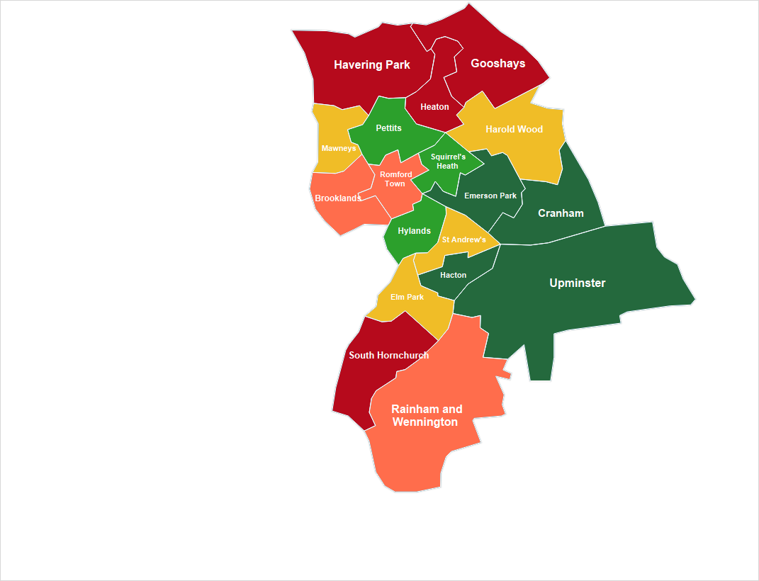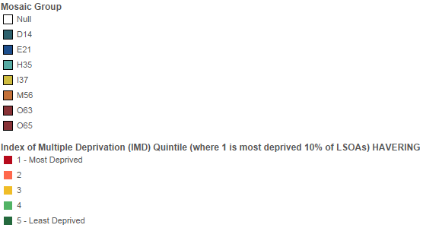

Source: Index of Multiple Deprivation (IMD 2015)

Overview

# Appendix 1: Ranking of all PHOF indicators

### Indicators

All indicators require context in order to understand them. In general, the indicator values are somewhat abstract, and have much greater usefulness when they are presented in comparison with other values of the same indicator. Here, indicators are presented showing changes over time and whether *high* or *low* is good for the population (or potential lower need for services). Each indicator for Havering is compared with values from all other geographical areas in London by ranking and a visual **RAG** status.

Tables in the appendix provide a summary of the Havering PHOF indicators[2] showing comparisons with London and England.

### How to read the tables



### Domain - Overarching indicators



### Domain - Improving the wider determinants of health



- continued



- continued



### Domain - Health improvement



- continued



- continued



### Domain - Health protection



- continued



### Domain - Healthcare public health and preventing premature mortality



- continued



- continued



# Appendix 2: Information about PHOF

The Public Health Outcomes Framework[3] (PHOF) sets out a high-level overview of public health outcomes, at national and local level, supported by a broad set of indicators. The indicators cover the full spectrum of what is understood as public health and what can be measured at the moment. The PHOF is published by Public Health England (PHE) under section 73B of the NHS Act 2006 as guidance that Local Authorities must pay due regard.

The PHOF concentrates on[4]:

* increased healthy life expectancy
* increased life expectancy
* reduced differences in healthy life expectancy between communities

The PHOF is used as a tool for local transparency and accountability, providing a means for benchmarking progress within each Local Authority and across authorities, and driving sector-led improvement where a Local Authority improves by learning from the experiences of peers. Alongside the NHS Outcomes Framework and Adult Social Care Outcomes Framework, the PHOF reflects the Government’s focus on improving health outcomes for the population and reducing inequalities in health, setting expectations for what the system as a whole wants to achieve.

The PHOF was first published in 2012 and there was a commitment not to make any changes for three years to allow it to become established during the transfer of public health responsibilities from the NHS to Local Authorities. The PHOF indicators were refreshed in May 2016, following a consultation in 2015; the amended PHOF indicator set has allowed PHE to make sure that the PHOF is still as relevant and as useful as possible, now that three years has passed.

Whilst information is provided on performance against the overarching outcomes, the nature of public health is such that the improvements in these outcomes will take years, even decades to see marked change. So, PHE have developed a set of indicators that help focus understanding of how well we are doing year by year nationally and locally on those things that matter most to public health that we know will help improve the overarching outcomes.

Indicators have been included in the PHOF as they cover the full spectrum of what PHE understand public health to be, and what can realistically be measured at the moment. PHE have been able to, and will continue to, clarify and expand the technical specifications to reflect ongoing development work. The 66 outcomes of the PHOF consist of a total of 219 indicators; there is more than one indicator associated with some outcomes because there may be a number of sub-indicators, e.g. based on sex and/or age.

The distribution of the number of outcomes across the different domains are shown in Table 2.

Table 2: Number of PHOF outcomes by domain

|  |  |  |
| --- | --- | --- |
| **Domain** | **Description** | **Outcomes** |
| Overarching indicators | High level public health outcomes | 2 |
| Improving the wider determinants of health | Wider factors that affect health and wellbeing | 18 |
| Health improvement | Protecting the population’s health from major incidents and other threats | 23 |
| Health protection | Helping people to live healthy lifestyles and make healthy choices | 7 |
| Healthcare public health and preventing premature mortality | Reducing numbers of people living with preventable ill health and people dying prematurely | 16 |
| Total | | 66 |

1. Public Health Outcomes Framework, Public Health England. <http://www.phoutcomes.info> (accessed 25.08.17)
2. Public Health Outcomes Framework, Havering. <http://www.phoutcomes.info/public-health-outcomes-framework#page/0/gid/1000049/pat/6/par/E12000007/ati/102/are/E09000016> (accessed 25.08.17)
3. Public Health Outcomes Framework, Public Health England. <http://www.phoutcomes.info> (accessed 25.08.17)
4. Public Health Outcomes Framework 2016 to 2019. <https://www.gov.uk/government/publications/public-health-outcomes-framework-2016-to-2019> (accessed 25.08.17)