

|  |  |
| --- | --- |
| Information requested | Live births by ward by month |
| Request from | Children’s services |
| Purpose | Live births figures will feed local models to determine childcare sufficiency and school place planning |
| Date completed | November 2017 |
| Analysis by | Tom Morgan (Principal Public Health Analyst) |

Summary

The number of live births in local authorities needs to be known in order to plan appropriate provision of maternity and health visiting services, nursery sufficiency and school places.

In Havering there were 3,400 live births in 2016. The highest number of live births occurred in the ward of *Brooklands* (320, 9%) and the North locality (1,260, 37%). The lowest number of live births occurred in the ward of *Upminster* (110, 3%) and the South locality (910, 27%).

The number of live births in Havering has increased by 4.4% per year since 2013; in England and Wales the rate has decreased slightly (-0.1%).

Annual live births

The number of live births in each ward per year are shown by Locality in Figure 1, Figure 2 and Figure 3.

|  |  |
| --- | --- |
|  | Figure |
| North |
|  | Figure |
| Central |
|  | Figure |
| South |

Quarterly live births

The number of live births in each Locality per quarter are shown in Figure 4.

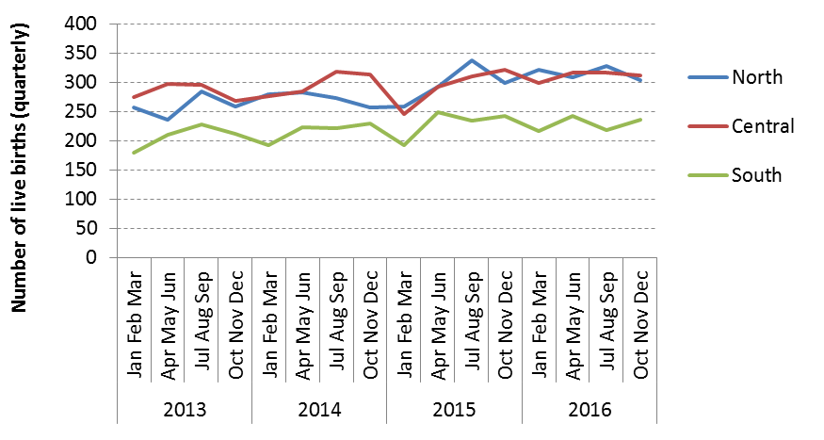

Figure

Conclusion

The wards with the greatest number of live births in 2016 were *Brooklands* (310), *Romford Town* (300) and *Gooshays* (270). The wards with the largest annual increases in recent years were *Gooshays* (13%), *Harold Wood* (11%) and *Elm Park* (9%). The wards with the fewest births in 2016 were *Upminster* (110) and *Emerson Park* (110). The wards with the smallest annual increases (-1%) in recent years were *Upminster* and *Romford Town*.

The number of live births in Havering is rising at a faster rate than the average for England and Wales. Within Havering, *Gooshays* and *Harold Wood* have together contributed one third (+50) of the overall recent increase in the number of live births.

Appendix

Table 1 shows the number of live births by ward (grouped by Locality) per quarter (grouped by calendar year).

Table

|  |  |  |  |  |  |  |  |  |  |  |  |  |  |  |  |  |  |  |  |
| --- | --- | --- | --- | --- | --- | --- | --- | --- | --- | --- | --- | --- | --- | --- | --- | --- | --- | --- | --- |
| Birth | | North | | | | | | Central | | | | | | South | | | | | |
| Year | Quarter | Gooshays | Harold Wood | Havering Park | Heaton | Mawneys | Pettits | Brooklands | Emerson Park | Hylands | Romford Town | Squirrel's Heath | St Andrew's | Cranham | Elm Park | Hacton | Rainham and Wennington | South Hornchurch | Upminster |
| 2013 | q1 | 44 | 45 | 43 | 61 | 41 | 23 | 73 | 17 | 33 | 74 | 43 | 34 | 24 | 36 | 19 | 42 | 36 | 22 |
| q2 | 41 | 37 | 50 | 57 | 24 | 27 | 84 | 26 | 38 | 75 | 47 | 28 | 32 | 38 | 33 | 36 | 48 | 24 |
| q3 | 65 | 54 | 43 | 53 | 34 | 36 | 74 | 20 | 32 | 83 | 49 | 38 | 22 | 44 | 31 | 49 | 58 | 24 |
| q4 | 53 | 43 | 44 | 43 | 45 | 31 | 76 | 22 | 31 | 61 | 38 | 41 | 24 | 35 | 25 | 39 | 47 | 42 |
| 2014 | q1 | 59 | 40 | 43 | 45 | 57 | 35 | 69 | 35 | 39 | 63 | 41 | 30 | 32 | 34 | 32 | 36 | 35 | 24 |
| q2 | 62 | 56 | 38 | 41 | 48 | 38 | 60 | 29 | 27 | 85 | 38 | 46 | 32 | 47 | 27 | 39 | 53 | 25 |
| q3 | 52 | 47 | 50 | 59 | 28 | 37 | 74 | 33 | 33 | 90 | 41 | 48 | 25 | 40 | 28 | 56 | 43 | 29 |
| q4 | 62 | 35 | 36 | 48 | 47 | 29 | 85 | 23 | 27 | 75 | 52 | 51 | 29 | 48 | 25 | 45 | 51 | 31 |
| 2015 | q1 | 52 | 53 | 40 | 41 | 45 | 28 | 57 | 16 | 30 | 59 | 47 | 37 | 25 | 41 | 27 | 41 | 32 | 27 |
| q2 | 63 | 54 | 49 | 49 | 41 | 36 | 78 | 28 | 28 | 78 | 52 | 28 | 26 | 47 | 33 | 49 | 65 | 29 |
| q3 | 80 | 52 | 47 | 62 | 55 | 42 | 78 | 27 | 33 | 78 | 45 | 50 | 38 | 45 | 23 | 49 | 53 | 26 |
| q4 | 70 | 54 | 44 | 64 | 40 | 27 | 84 | 28 | 46 | 77 | 49 | 38 | 27 | 50 | 28 | 54 | 57 | 27 |
| 2016 | q1 | 65 | 61 | 48 | 61 | 49 | 37 | 64 | 25 | 33 | 70 | 57 | 50 | 33 | 40 | 27 | 41 | 50 | 26 |
| q2 | 87 | 58 | 45 | 55 | 31 | 33 | 86 | 21 | 33 | 75 | 57 | 44 | 39 | 61 | 33 | 40 | 43 | 26 |
| q3 | 75 | 53 | 51 | 53 | 60 | 36 | 86 | 39 | 37 | 77 | 35 | 42 | 37 | 51 | 36 | 32 | 38 | 24 |
| q4 | 56 | 47 | 45 | 62 | 43 | 51 | 87 | 28 | 46 | 77 | 42 | 32 | 28 | 46 | 34 | 53 | 42 | 33 |

Table 2 shows the number of live births by Locality per quarter (grouped by calendar year).

Table

|  |  |  |  |  |  |
| --- | --- | --- | --- | --- | --- |
| Year | Quarter | North | Central | South | *Havering* |
| 2013 | Jan Feb Mar | 257 | 274 | 179 | *710* |
| Apr May Jun | 236 | 298 | 211 | *745* |
| Jul Aug Sep | 285 | 296 | 228 | *809* |
| Oct Nov Dec | 259 | 269 | 212 | *740* |
| 2014 | Jan Feb Mar | 279 | 277 | 193 | *749* |
| Apr May Jun | 283 | 285 | 223 | *791* |
| Jul Aug Sep | 273 | 319 | 221 | *813* |
| Oct Nov Dec | 257 | 313 | 229 | *799* |
| 2015 | Jan Feb Mar | 259 | 246 | 193 | *698* |
| Apr May Jun | 292 | 292 | 249 | *833* |
| Jul Aug Sep | 338 | 311 | 234 | *883* |
| Oct Nov Dec | 299 | 322 | 243 | *864* |
| 2016 | Jan Feb Mar | 321 | 299 | 217 | *837* |
| Apr May Jun | 309 | 316 | 242 | *867* |
| Jul Aug Sep | 328 | 316 | 218 | *862* |
| Oct Nov Dec | 304 | 312 | 236 | *852* |

Table 3 shows the number of live births by Locality per year.

Table

|  |  |  |  |  |
| --- | --- | --- | --- | --- |
| Year | North | Central | South | *Havering* |
| 2013 | 1,037 | 1,137 | 830 | *3,004* |
| 2014 | 1,092 | 1,194 | 866 | *3,152* |
| 2015 | 1,188 | 1,171 | 919 | *3,278* |
| 2016 | 1,262 | 1,243 | 913 | *3,418* |